**Date: 29/01/2020**

**Amazon EC2**

* Introduction to Amazon EC2
* EC2 Benefits
* Use EC2
* EC2 Features
* EC2 Instance Types
* Pricing
* Lab Exercise

***Introduction to Amazon EC2***

Amazon Elastic Compute Cloud (Amazon EC2) is a web service that provides resizable compute capacity in the cloud

Amazon EC2’s simple web service interface allows you to obtain and configure capacity with minimal friction.

It provides you with complete control of your computing resources and lets you run on Amazon’s proven computing environment.

Amazon EC2 reduces the time required to obtain and boot new server instances to minutes, allowing you to quickly scale capacity, both up and down, as your computing requirements change.

Amazon EC2 changes the economics of computing by allowing you to pay only for capacity that you actually use.

Amazon EC2 provides developers the tools to build failure resilient applications and isolate themselves from common failure scenarios

***Amazon EC2 Benefits***

* **Elastic Web-Scale Computing**

Amazon EC2 enables you to increase or decrease capacity within minutes, not hours or days. You can commission one, hundreds or even thousands of server instances simultaneously because this is all controlled with web service APIs, your application can automatically scale itself up and down depending on its needs.

* **Completely Controlled**

You have complete control of your instances. You have root access to each one, and you can interact with them as you would any machine. You can stop your instance while retaining the data on your boot partition and then subsequently restart the same instance using web service APIs. Instances can be rebooted remotely using web service APIs. You also have access to console output of your instances.

* **Flexible Cloud Hosting Services**

You have the choice of multiple instance types, operating systems, and software packages. Amazon EC2 allows you to select a configuration of memory, CPU, instance storage, and the boot partition size that is optimal for your choice of operating system and application. For example, your choice of operating systems includes numerous Linux distributions, and Microsoft Windows Server.

* **Designed for use with other Amazon Web Services**

Amazon EC2 works in conjunction with Amazon Simple Storage Service (Amazon S3), Amazon Relational Database Service (Amazon RDS), Amazon SimpleDB and Amazon Simple Queue Service (Amazon SQS) to provide a complete solution for computing, query processing and storage across a wide range of applications.

* **Reliable**

Amazon EC2 offers a highly reliable environment where replacement instances can be rapidly and predictably commissioned. The service runs within Amazon’s proven network infrastructure and data centers. The Amazon EC2 Service Level Agreement commitment is 99.95% availabilityfor each Amazon EC2 Region.

* **Inexpensive**

Amazon EC2 passes on to you the financial benefits of Amazon’s scale. You pay a very low rate for the compute capacity you actually consume. See Amazon EC2 Instance Purchasing Options for a more detailed description.

* **Secure**

Amazon EC2 works in conjunction with Amazon VPC to provide security and robust networking functionality for your compute resources.

Your compute instances are located in a Virtual Private Cloud (VPC) with an IP range that you specify. You decide which instances are exposed to the Internetand which remain private.

Security Groupsand networks ACLs allow you to control inbound and outbound network access to and from your instances.

You can connect your existing IT infrastructure to resources in your VPC using industry-standard encrypted IPsec VPN connections.

You can provision your EC2 resources as Dedicated Instances. Dedicated Instances are Amazon EC2 Instances that run on hardware dedicated to a single customerfor additional isolation.

If you do not have a default VPC**,** you must create a VPC and launch instances into that VPC to leverage advanced networking features such as private subnets, outbound security group filtering, network ACLs, Dedicated Instances, and VPN connections.

* **On-Demand Instances**

On-Demand Instances let you pay for compute capacity by the hour with no long-term commitments.

This frees you from the costs and complexities of planning, purchasing, and maintaining hardware and transforms what are commonly large fixed costs into much smaller variable costs.

* **Reserved Instances**

Reserved Instances provide you with a significant discount (up to 75%) compared to On-Demand Instance pricing.

There are three Reserved Instance payment options (No Upfront, Partial Upfront, All Upfront) that enable you to balance the amount you pay upfront with your effective hourly price.

The Reserved Instance Marketplace is also available, which provides you with the opportunity to sell Reserved Instances if your needs change.

* **Spot Instances**

Spot Instances allow customers to bid on unused Amazon EC2 capacity and run those instances for as long as their bid exceeds the current Spot Price.

***Use EC2***

To use Amazon EC2, you simply:

* Select a pre-configured, template Amazon Machine Image (AMI) to get up and running immediately. Or create an AMI containing your applications, libraries, data, and associated configuration settings.
* Configure security and network access on your Amazon EC2 instance..
* Choose which instance type(s) you want, then start, terminate, and monitor as many instances of your AMI as needed, using the web service APIs or the variety of management tools provided.
* Determine whether you want to run in multiple locations, utilize static IP endpoints, or attach persistent block storage to your instances.
* Pay only for the resources that you actually consume, like instance-hours or data transfer.

**Date: 3/2/2020**

***Features of EC2***

Amazon EC2 provides a number of powerful features for building scalable, failure resilient, enterprise class applications.

* **Amazon Elastic Block Store**

Amazon Elastic Block Store (EBS) offers persistent storage for Amazon EC2 instances.

Amazon EBS volumes are highly available, highly reliable volumes that can be leveraged as an Amazon EC2 instance’s boot partition or attached to a running Amazon EC2 instance as a standard block device

* **EBS-Optimized Instances**

For an additional, low, hourly fee, customers can launch selected Amazon EC2 instances types as EBS-optimized instances

* **Multiple Locations**

Amazon EC2 provides the ability to place instances in multiple locations. Amazon EC2 locations are composed of Regions and Availability Zones. Availability Zones are distinct locations that are engineered to be insulated from failures in other Availability Zones and provide inexpensive, low latency network connectivity to other Availability Zones in the same Region. By launching instances in separate Availability Zones, you can protect your applications from failure of a single location.

* **Elastic IP Addresses**

Elastic IP addresses are static IP addresses designed for dynamic cloud computing. An Elastic IP address is associated with your account not a particular instance, and you control that address until you choose to explicitly release it. Unlike traditional static IP addresses, however, Elastic IP addresses allow you to mask instance or Availability Zone failures by programmatically remapping your public IP addresses to any instance in your account

* **Amazon Virtual Private Cloud**

Amazon Virtual Private Cloud (Amazon VPC) lets you provision a logically isolatedsection of the Amazon Web Services (AWS) Cloud where you can launch AWS resources in a virtual network that you define.

You have complete control over your virtual networking environment, including selection of your own IP address range, creation of subnets, and configuration of route tables and network gateways. You can also create a Hardware Virtual Private Network (VPN) connection between yourcorporate datacenter and your VPCand leverage the AWS cloud as an extension of your corporate datacenter.

* **Amazon CloudWatch**

Amazon CloudWatch is a web service that provides monitoring for AWS cloud resources and applications, starting with Amazon EC2. It provides you with visibility into resource utilization, operational performance, and overall demand patterns—including metrics such as CPU utilization, disk reads and writes, and network traffic. You can get statistics, view graphs, and set alarms for your metric data.

* **Auto Scaling**

With Auto Scaling, you can ensure that the number of Amazon EC2 instances you’re using scales up seamlessly during demand spikes to maintain performance, and scales down automatically during demand lulls to minimize costs.

Auto Scaling is particularly well suited for applications that experience hourly, daily, or weekly variability in usage.

Auto Scaling is enabled by Amazon CloudWatchand available at no additional charge beyond Amazon CloudWatch fees

* **Elastic Load Balancing**

Elastic Load Balancing automatically distributes incoming application traffic across multiple Amazon EC2 instances. It enables you to achieve even greater fault tolerance in your applications, seamlessly providing the amount of load balancing capacity needed in response to incoming application traffic.

* **Dense Storage Instances**

Customers requiring very high storage density per instance, and high sequential I/O for data-intensive applications like Massively Parallel Processing (MPP) data warehouse, MapReduce and Hadoop distributed computing, and log and data processing can benefit from Dense Storage instances. Dense Storage instances are an Amazon EC2 instance type that can provide customers with sequential I/O throughout of up to 3.9 GB/s and provide customers with up to 48 TB of instance storage across 24 hard diskdrives

* **VM Import/Export**

VM Import/Export enables you to easily import virtual machine images from your existing environment to Amazon EC2 instances and export them back at any time

* **AWS Marketplace**

AWS Marketplace is an online store that helps you find, buy and quickly deploy software that runs on AWS. You can use AWS Marketplace’s 1-Click deployment to quickly launch pre-configured software and be charged for what you use, by the hour or month. AWS handles billing and payments, and software charges appear on your AWS bill.

***EC2 Instance types***

* **General Purpose**

T2 instances, T3

M5 instances

M4 instances

* **Compute Optimized**

C4 instances

C3 instances

* **Memory Optimized**

R3 instances, X1, X1e

* **GPU**

G2 instances

* **Storage Optimized**

R3 instances

* **Dense Storage Instances**

I2 instances

***Amazon EC2 pricing***

Pay only for what you use. There is no minimum fee. Estimate your monthly bill using AWS Simple Monthly Calculator. The prices listed are based on the Region in which your instance is running

**Free Tier\***

As part of AWS’s Free Tier, new AWS customers can get started with Amazon EC2 for free. Upon sign-up, new AWS customers receive the following EC2 services each month for one year:

**1.** 750 hours of EC2 running Linux, RHEL, or SLES t2.micro instance usage

**2.** 750 hours of EC2 running Microsoft Windows Server t2.micro instance usage

**3.** 750 hours of Elastic Load Balancing plus 15 GB data processing

**4.** 30 GB of Amazon Elastic Block Storage in any combination of General Purpose (SSD) or Magnetic, plus **5.** 2 million I/Os (with Magnetic) and 1 GB of snapshot storage  
**6.** 15 GB of bandwidth out aggregated across all AWS services

**7.** 1 GB of Regional Data Transfer

***Create one Amazon web account***

* Create a new Amazon web account using the basic information in Amazon web console .

***Creating a ON Demand instance***

* Login to web console
* Select compute
* Open the amazon EC2 console
* Select the region MUMBAI
* Check the service health
* Click on EC2 dashboard
* Click on instances
* Click on launch instance
* Select AMI ( Amazon Machine image) (1st one)
* Select instance type
* Select type “t2.micro” -- free tier
* Click next “configure instance details”
* Select defaults
* Click on next “add storage”
* Select defaults
* Add the tag
* Click on configure “security group”
* Select defaults
* Click on review & launch
* Verify the summary, then drag down
* Click on launch button
* Select a key pair
* Enter key pair name
* Click on download key pair
* Click on launch instance
* Check instance staus == running

***How to connect AMI from windows client***

* Login to client windows
* Convert the key pair file from *.pem to *.ppk format
* Open Puttygen
* Click on load
* Select *.pem file
* Save as *.ppk file
* Click on save private key
* Save the file as *.ppk
* Open putty
* Give the public ip address
* Click on SSH, expand select auth
* Select *.ppk file
* Click on open
* Give username: ec2_user

**Note:** To go to the /root command is #sudo su -

***How to terminate the instance***

* Click on the Actions
* Select instance state
* Click on stop
* Again click on actions, instance state, terminate.

**Date: 4/2/2020**

***Creating Reserved Instances***

* Login to web console
* Select EC2
* Select reserved instance
* Select options
* Click on search
* Select last one
* Add to cart
* View cart

**Note:** Don’t click on purchase. In real time it is the way to create reserved instances.

***Creating spot instances***

* Select spot requests
* Target capacity –1
* Launch template – none
* AMI – select
* Instance type – c4.4x large
* Network – default
* Availability zone – any
* Ebs volume – defaults
* Ebs optimized – no changes
* Instance store – no
* Monitoring – no
* Tenancy – shared
* IAM (identity access management)

***To configure webserver on amazon linux instance***

* Configure webserver and to verify using elastic public ip
* Launch amazon linux instance and login to your instance
* Connect to linux instance from windows using PUTTY
* Open putty
* Give ip and username
* Switch to root user ------ #sudo su –
* # yum install httpd –y
* # chkconfig httpd on
* Service httpd start
* vi /var/www/html/index.html

Write the info in the file-------- this is aws site

* save the file
* create an inbound rule to allow http on port 80
* open aws console
* Go to EC2 dashboard
* Select the instance
* Go to right end
* Select the security group
* Click on launch wizard -1
* Click on edit button
* Click on add rule
* Add http rule
* Use typr http
* Use source select any where
* Click on save
* Open web browser provide DNS ip
* Verify.

***How to give password authentication in AWS by using SSH***

* Login to linux instance through putty
* User name ec2-user
* Switch into root user # sudo su –
* Create user account

# useradd ali

# passwd ali

* Open the config file of SSH

# vi /etc/ssh/sshd_config

* Set line numbers
* esc: set nu
* Go to line no: 63

Make the changes----Password authentication YES (by default it will be no)

* Save and exit :wq!
* # service sshd restart
* Go to putty
* Give the public IP
* Click on open
* Give user name and password

**Date: 5/2/2020**

**Amazon EBS**

* Introduction to Amazon EBS
* EBS Size and Capacity
* EBS Benefits
* Use Cases
* Volume Types
* EBS Snapshots
* EBS Features
* Pricing
* Instance Store-backed Instances
* EBS-backed Instances
* Lab Exercise

***Amazon EBS***

* Amazon Elastic Block Store (Amazon EBS) provides **persistent storage volumes** for Amazon EC2 instances that can be attached to a running instance.
* Each Amazon EBS volume is automatically **replicated** within its Availability Zone to protect you from component failure, offering **high availability** and **durability**.
* With Amazon EBS, you can scale your usage **up or down** within minutes – all while paying a low price for only what you provision

***Storage technologies***

There are mainly 3 types of storage technologies

* **DAS ( direct attached storage)**

storage hardware that connects to a single server. Also called Direct attached storage (DAS). DAS is local storage and one to one relationship.

* **NAS (network attached storage)**
* Storage subsystem that connects directly to the LAN
* Has a processor and an operating system
* NAS lives “infront” of the server, it is called “appliance”.
* **Benefits of NAS**
* Work independently without host support
* Centralizes control
* Provide across platform file server
* Minimal downtime
* Streamlined architecture
* Reduced server I/O bottlrneck
* Data availability, stored data is shared
* Efficient allocation and use of resources
* Simplicity
* Increased productivity
* Connectivity
* **Disadvantages of NAS**
* Storage traffic travels across the messaging network, so network performance is impacted
* Need protocol (NFS, CIFS etc) support, cannot work in block level
* Sharing data is only in file level, cannot share resources in storage device level.
* **SAN ( storage area network)**
* A network whose primary purpose is the transfer of data between computer systems and storage elements and among storage elements. Abbreviated SAN (SNIA).
* A high-speed network, comparable to a LAN, that allows the establishment of direct connections between storage devices and processors centralized to the extent support by the distance of fibre channel. (IBM)
* A server storage or area network. A network linking computing devices to disk or tape arrays and other devices over fibre channel. (BROCADE)
* **Benefits of SAN**
* Pooling of storage devicesfor better utilization
* Increase the availability of storage
* Increased backup performance
* Increase of operation distance, useful for disaster recovery and remot mirroring.
* **Disadvantages of SAN**
* Difficult to the interperability of storage devices between OS, database and technologies
* Complexity – difficult to manage the systems without powerful software to manage the storage devices.
* Lack of specialised staff resources
* Cost considerations, high startup cost for SME scalability, reliability and data protection affects cost.
* Too many devices and vendors to enumerate.

***Elastic IP address***

Whatever the public IP assigned by the AWS is not permanent. Every time it will change so that we can give permanent IP, it is called elastic IP address.

**Note:** If elastic IP is not released it will be charged. So release elastic IP address.

***To assign Elastic IP address to an instance***

* Open AWS web console
* Click on EC2 dashboard
* Click on “network security”
* Click on elastic IP
* Click on allow new address button
* Click on allocate
* Click on close
* Open browser check the web site using elastic IP

***To release elastic IP***

* Click on EC2 dashboard
* Expand “network security”
* Click on elastic IP
* Click on action button
* Click on disassociate address
* Click on action button
* Click on release button
* Click on release

**Date: 7/2/2020**

***Launching to windows instance***

* Login to web console
* Click on instance
* Click on launch instance
* Select amazon machine image (Microsoft windows server) – free tier
* Choose instance type ( t2.micro)
* Click on configure instance details
* Use default values
* Click on add storage
* Use defaults
* Click on tag instances
* Click on add tag
* Click on configure security group
* Create new security group
* Use defaults
* Click on review and launch
* Verify the summary and then drag down
* Click on launch button
* Select an existing keypair
* Click on download key pair
* Click on launch instance
* Click on view instance
* Click on EC2 dashboard
* Connect windows instances from windows client
* Select the instances
* Click on connect
* Click on download remote desktop file
* Click on get password
* Click on choose file
* Click on decrypt password
* Select password
* Click close
* Click on download RDP file
* Provide username: administrator
* Password
* Click on connect
* verify

**Amazon EBS**

1. SSD – solid state disc
2. IOPS – input output operations per second

***To create an EBS volume***

* Login to AWS console
* Click on EC2
* Click on EC2 dashboard
* Select elastic block storage
* Click on volumes
* Volume type: general purpose SSD
* Size: 2g
* IOPS: 100/3000
* Throughptet – not applicable
* Availability zone – Mumbai
* Use defaults of remaining
* Click on create volume
* Verify volume successfully created
* Select volume check status – available
* Give the name to volume

***Attaching and detaching EBS volume in windows***

* Create windows instance
* Go to EC2 dashboard
* Choose elastic block store
* Click on volume
* Click on action button
* Click on attach volume
* Select windows instance
* Click on attach
* Verify the availability of new volume
* Login to windows instance
* Go to run command
* Type **diskmgmt.msc**
* Verify the volume
* Right click on disk, click on online
* Format the volume

***To create a snapshot and restore EBS volume***

* Create 2 folders in D-drive
* Now create a snapshot
* Click on EC2 dashboard
* Click on EBS
* Click on action
* Click on create a snapshot
* Click on create
* Verify the snapshot

***To delete the volume***

* Go to windows disk management
* Right click on the disk, make it offline
* Click on EC2 dashboard
* Expand EBS
* Select volume
* Click on action button
* Click on delete volume
* Go to windows check the D-drive
* Now delete volume
* Verify volume is deleted

***To restore the volume***

* Click on EC2 dashboard
* Expand EBS
* Select snapshot
* Click on action button
* Click on create volume
* Select defaults
* Verify volume is created

***To expand the size of EBS volume***

* Click on EC2 dashboard
* Select snapshot option
* Click on action
* Click on create volume
* Select size
* Click on availability zone
* Click on create volume
* Verify
* Now attach the expanded volume to your instance
* Select the instance
* Click on attach button
* Verify the size
* Now right click on D-drive extend the volume
* Now check the D-drive

***To detach volume***

* Click on EC2 dashboard
* Select the volume
* Click on action button
* Click on detach volume
* Click yes
* Go to windows instance
* Check the drive
* Select linux instance
* Connect linux instance
* Switch to root user
* # sudo su –
* # fdisk –l

**Date: 11/2/2020**

**AWS Identity and Access Management (IAM)**

1. Introduction to AWS Identity and Access Management (IAM)
2. IAM Features
3. Multi-Factor Authentication
4. Virtual MFAS
5. User’s Security Credentials
6. Temporary security credentials
7. Manage Permissions and Policies
8. Manage Users, Use Cases
9. IAM Groups
10. Accessing IAM

***AWS Identity and Access Management (IAM)***

AWS Identity and Access Management (IAM) enables us to securely control access to AWS services and resources for the users.

Using IAM, we can create and manage AWS users and groups, and use permissions to allow and deny their access to AWS resources.

AWS Identity and Access Management (IAM) is a web service that enables Amazon Web Services (AWS) customers to **manage users and user permissions** in AWS. The service is targeted at organizations with **multiple users** or systems in the cloud that use AWS products such as **Amazon EC2**, Amazon **RDS**, and the **AWS Management Console**. With IAM, we can **centrally** manage users, security credentials such as **access keys**, and permissions that control AWS resources for the users.

***Free to use***

AWS Identity and Access Management is a feature of our AWS account offered at **no additional charge**. We will be charged only for use of other AWS products by our IAM users

***IAM features***

***Shared access to our AWS account***

* We can **grant other people permission to administer and use resources in our AWS account** without sharing our password or access key.

***Granular permissions***

* we can grant **different permissions** to different people for different resources.

For example, we might allow some users **for complete access** to Amazon Elastic Compute Cloud (Amazon EC2), Amazon Simple Storage Service (Amazon S3), Amazon RDS, and other AWS products.

For other users, we might allow **read-only access** to just some S3 buckets, or permission to administer just some EC2 instances, or to access our billing information but nothing else.

***Secure access to AWS resources for applications that run on Amazon EC2***

* We can use IAM features to **securely access applications** that run on EC2 instances**.**

***Multi-factor authentication (MFA)***

* We can add two-factor authentication to our account and to individual users for extra security.
* With MFA, our users must provide not only a password or access key to work with the account, **but also a code from a specially configured device** that will be given by vendor (chargeable).

***Identity federation***

* We can allow users who already have passwords elsewhere—for example, in our corporate network or with an Internet identity provider—to get temporary access to our AWS account.

***Identity information for assurance***

* If we use AWS CloudTrail, we receive log records that include information about those who made requests for resources in our account. That information is based on IAM identities.

***Enhanced Security***

* IAM enables security best practices by allowing us to grant unique security credentials to users and groups to specify which AWS service APIs and resources we can access.

***Temporary Credentials***

* In addition to define access permissions directly to users and groups, IAM lets us to create roles. Roles allow us to define a set of permissions and authentication for users or EC2 instances.

***Flexible security credential management***

* We can assign a range of security credentials including passwords, key pairs, and X509 certificates. we can also enforce multi-factor authentication (MFA) on users who access the AWS Management Console or use APIs.

***Leverage external identity systems***

* We can use IAM to grant our employees and applications access to the AWS Management Console and to AWS service APIs. AWS supports federation from corporate systems like Microsoft Active Directory, as well as external Web Identity Providers like Google and Facebook

***Seamlessly integrated into AWS services***

* IAM is integrated into most AWS services through AWS Management Console that will take effect throughout our AWS environment.

***Multi-Factor Authentication***

* AWS Multi-Factor Authentication (MFA) is a simple best practice that adds an extra layer of protection on top of our user name and password.
* With MFA enabled, when a user signs in to an AWS website or environment, they will be prompted for their user name and password (the first factor—what they know), as well as for an authentication code from their AWS MFA device (the second factor—what they have). Taken together, these multiple factors provide increased security for our AWS account settings and resources.
* We can enable MFA for our AWS account and for individual IAM users we have created under our account.
* After we've obtained a **supported hardware** or **virtual MFA device**, AWS does not charge any additional fees for using MFA.

***Virtual MFA Applications***

* MFA Applications for our smartphone can be installed from the application store that is specific to our phone type.

The following table lists some applications for different smartphone types.

|  |  |
| --- | --- |
| *Android* | *AWS Virtual MFA;  Google Authenticator* |
| *iPhone* | *Google Authenticator* |
| *Windows Phone* | *Authenticator* |
| *Blackberry* | *Google Authenticator* |

***Manage Users' Security Credentials***

* AWS Identity and Access Management (IAM) lets us manage several types of long-term security credentials for IAM users:
* **Passwords** – Used to sign in to secure AWS pages, such as the AWS Management Console, the AWS Discussion Forums, and the AWS Premium Support site.
* **Access keys and Key Pairs** – Used to make secure Query protocol requests to any AWS service API.
* we can assign AWS security credentials to our IAM users by using the API, CLI, or AWS Management Console. we can rotate or revoke these credentials whenever we want.
* In addition to managing these user credentials, we can further enhance the security of IAM user access to AWS by enforcing the use of **multi-factor authentication (MFA).**

***Temporary security credentials***

* IAM also lets us grant any user temporary security credentials with a **defined expiration** for access to our AWS resources.

For example, temporary access is useful when:

* Creating a mobile app with third-party sign-in.
* Creating a mobile app with custom authentication.
* Using our organization's authentication system to grant access to AWS resources.
* Using our organization's authentication system and SAML to grant access to AWS resources.
* Security Assertion Markup Language (SAML, pronounced sam-el) is an XML-based, open-standard data format for exchanging authentication and authorization data between parties, in particular, between an identity provider and a service provider
* Using web-based Single Sign-On (SSO) to the AWS Management Console.

***Manage Permissions and Policies***

* Permissions let us specify, who has access to AWS resources and which actions they can perform on those resources.
* Every AWS Identity and Access Management (IAM) user starts with no permissions.
* In other words, by default, users can do nothing, not even view their own access keys.
* To give a user permission to do something, we can add the permission to the user (that is, **attach a policy** to the user), or add the user to a group that has the **desired permission**

***Using Groups for Easy Administration***

* A group is a collection of IAM users.
* Groups let us assign permissions to a collection of users, which can make it easier to manage the permissions for those users.
* For example, in almost all the companies, we could have a group called Admins and give that group the types of permissions that administrators typically need. Any user in that group automatically has the permissions that are assigned to the group. If a new user joins our organization and should have administrator privileges, we can assign the appropriate permissions by adding the user to that group. Similarly, if a person changes jobs in our organization, instead of editing that user's permissions, we can remove him or her from the old group and add him or her to the new group.

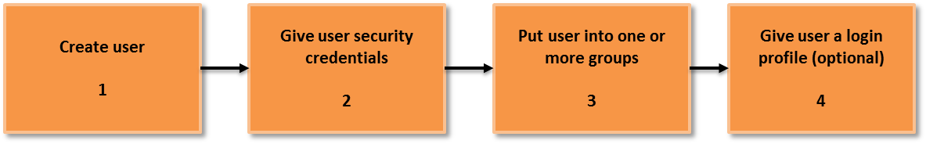

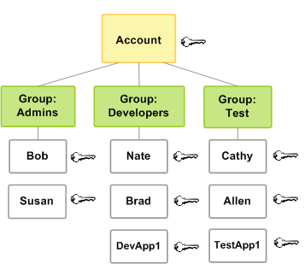

***To create IAM user, assign password, change password policy***

* Login to AWS console
* Select security, identity and compliance
* Click IAM service
* From IAM dashboard
* Select group
* Click on new group
* Give the group name
* Click next
* In filter type – EC2F
* Check the box amazon EC2 full access
* Click next
* Click on create group
* Verify
* Create another group
* Click in create group
* Give the full access S3 storage
* In filter type: S3f
* Check the box amazon full access
* Click next
* Click on create group
* Verify
* Attach the policy
* Create the users and join the EC2 admin group and S3 admin group
* Create another user and EC2 full access and S3 full access policy
* Click on IAM dashboard
* Select users
* Click on add users
* Create user ali and join the EC2 admin group
* Select ali
* Access type: AWS management console access
* Dragdown
* Give console custom password
* Click on next permissions
* Under group column
* Select EC2 admin group
* Click on next review
* Verify user details
* Download the .CSV file
* Click on close button
* Again create another user raja
* Join to S3 admin group
* Select user
* Add user
* Username: raja
* Console password: ****
* Drag down
* Click on next permissions
* Select S3 admin permissions
* Click on next review
* Verify user details
* Select user
* Download .CSV file
* Click on close
* Create another user nivas without joining any group
* Attach EC2full access and S3full access policy
* Select user
* Add user
* Username: nivas
* Console password: *****
* Drag down
* Click on next permission
* Click on attach existing policies directly box
* Filter type EC2f
* Select amazon EC2full access check box
* Filter type search for S3f
* Select amazon S3full access check box
* Click on next review
* Verify user details
* Download .CSV file
* Click on close
* Verification
* Open web browser
* Type: [**https://123456789.signin.aws.amazon.com/console**](https://123456789.signin.aws.amazon.com/console)
* Click on sign in
* Click on S3 verify access
* Now select EC2 service
* Now he can access
* Delete the users
* IAM dashboard
* Select users
* Drop down action button
* Delete users
* YES button
* Verify
* Delete groups
* IAM dashboard
* Select groups
* Drag down
* Click on action
* Delete group
* Click on YES

***To create Multifactor authentication (MFA)***

* Install google authenticator in your android mobile
* IAM dashboard
* Click on user
* Click on security credentials
* Click on pen sign for assigned MFA device
* Select a virtual MFA device
* Click on next
* Click on next
* Bar code will create
* Scan the bar code from your mobile google authenticator application
* Now tpe 6 digit bar code in authentication code 1
* Once the barcode changes
* Retype 6 digit bar code in authentication 2
* Click on finish
* Now login as user
* Open the browser type MFA 6 digit coder
* Click on submit
* Verify user successfully logged in

**Date: 12/2/2020**

**Amazon S3**

1. Introduction to Amazon S3
2. S3 Benefits
3. S3 user cases
4. S3 key features
5. Storage classes
6. S3 pricing
7. S3 data size
8. Website on S3
9. Lab exercise

***Amazon S3***

* Amazon Simple Storage Service (Amazon S3), provides secure, durable, highly-scalable object storage.
* Amazon S3 stores data as objects within resources called "buckets." You can store as many objects as you want within a bucket, and write, read, and delete objects in your bucket. Objects can be up to **5 terabytes in size**.
* Amazon S3 is easy to use, with a **simple web service interface** to store and retrieve any amount of data from anywhere on the web.

***S3 Benefits***

***Durable***

Amazon S3 provides durable infrastructure to store important data and is designed for durability of 99.999999999% of objects.

***Low Cost***

Amazon S3 allows you to store large amounts of data at a very low cost.

***Available***

Amazon S3 Standard is designed for up to 99.99% availability of objects over a given year and is backed by the Amazon S3 Service Level Agreement, ensuring that you can rely on it when needed.

***Secure***

Amazon S3 supports data transfer over SSL and automatic encryption of your data once it is uploaded. You can also configure bucket policies to manage object permissions and control access to your data using AWS Identity and Access Management (IAM).

***Scalable***

With Amazon S3, you can store as much data as you want and access it when needed. You can stop guessing your future storage needs and scale up and down as required, dramatically increasing business agility.

***Send Event Notifications***

Amazon S3 can send event notifications when objects are uploaded to Amazon S3. Amazon S3 event notifications can be delivered using Amazon SQS or Amazon SNS enabling you to trigger workflows, alerts, or other processing.

***S3 integrations***

Include Amazon CloudFront, Amazon CloudWatch, Amazon Kinesis, Amazon RDS, Amazon Glacier, Amazon EBS, Amazon DynamoDB, Amazon Redshift, Amazon Route 53, Amazon EMR, Amazon VPC, Amazon KMS, and AWS Lambda

***S3 Key Features***

***Storage and Security***

Amazon S3 stores data as objects within resources called "buckets." You can store as many objects as you want within a bucket, and write, read, and delete objects in your bucket. Objects can be up to **5 terabytes in size**.

You can control access to the bucket (who can create, delete, and retrieve objects in the bucket for example), view access logs for the bucket and its objects, and choose the AWS region where a bucket is stored to optimize for latency, minimize costs, or address regulatory requirements

***Cross-Region Replication***

Cross-region replication (CRR) provides automated, fast, reliable data replication across AWS regions. Every object uploaded to an S3 bucket is automatically replicated to a destination bucket in a different AWS region that you choose

***Event Notifications***

Amazon S3 event notifications can be sent when objects are uploaded to or deleted from Amazon S3

***Versioning***

Amazon S3 allows you to enable versioning so you can preserve, retrieve, and restore every version of every object stored in an Amazon S3 bucket.

***Lifecycle Management***

Amazon S3 provides a number of capabilities to manage the lifecycle of your data, including automated migration of older data from S3 Standard to S3 Standard - Infrequent Access and Amazon Glacier

***Encryption***

Amazon S3 encrypts data in transit via SSL-encrypted endpoints and can also encrypt data at rest with three options for managing encryption keys: directly by S3, through AWS Key Management Service (AWS KMS), or you can provide your own keys

***Security and Access Management***

Amazon S3 provides several mechanisms to control and monitor who can access your data as well as how, when, and where they can access it. VPC endpoints allow you to create a secure connection without a gateway or NAT instances

***S3 Storage Classes***

***Amazon S3 Storage Classes***

Amazon S3 offers a range of storage classes designed for different use cases. These include

* **Amazon S3 Standard for general-purpose storage** of frequently accessed data,
* **Amazon S3 Standard - Infrequent Access for long-lived**, but less frequently accessed data, and
* **Amazon Glacier** for long-term archive.

Amazon S3 also offers configurable lifecycle policies for managing your data throughout its lifecycle. Once a policy is set, your data will automatically migrate to the most **appropriate storage class without any changes to your application**

***Amazon Glacier - Archive***

* Amazon Glacier is a secure, durable, and extremely low-cost storage service for data archiving.
* Amazon Glacier is optimized for data that is rarely accessed and a **retrieval time of several hours**.
* But from Nov 2017 onwards retrieval time is reduced to minutes.

***Key Features***

* Designed for durability of 99.999999999% of objects
* Supports SSL encryption of data in transit and at rest
* Vault Lock feature enforces compliance via a lockable policy
* Extremely low cost design is ideal for long-term archive
* Lifecycle management for automatic migration of objects

***Announcing Amazon S3 Reduced Redundancy Storage***

* **Reduced Redundancy Storage (RRS)** is a new storage option within Amazon S3 that enables customers to reduce their costs by storing non-critical, reproducible data at lower levels of redundancy than Amazon S3’s standard storage.
* It provides a cost-effective, highly available solution for distributing or sharing content that is durably stored elsewhere, or for storing **thumbnails, transcoded media**, or other **processed data** that can be easily reproduced.
* Both the standard and RRS storage options are designed to be highly available, and both are backed by **Amazon S3’s Service Level Agreement**

***S3 Pricing***

***Amazon S3 Pricing***

Pay only for what you use. There is no minimum fee. Estimate your monthly bill using the AWS Simple Monthly Calculator. Prices are based on the location of your Amazon S3 bucket

***AWS Free Usage Tier***

* As part of the AWS Free Usage Tier, you can get started with Amazon S3 for free. Upon sign-up.
* New AWS customers receive 5 GB of Amazon S3 standard storage, 20,000 Get Requests, 2,000 Put Requests, and 15GB of data transfer out each month for one year

***Data Transfer Pricing***

* The below is the example of Amazon S3 pricing

***Pricing Example***

With Amazon S3, you pay only for the storage you actually use. There is no minimum fee and **no setup cost**

Storage Example:  
Assume you store 100GB (107,374,182,400 bytes) of standard Amazon S3 storage data in your bucket for 15 days in March, and 100TB (109,951,162,777,600 bytes) of standard Amazon S3 storage data for the final 16 days in March.

At the end of March, you would have the following usage in Byte-Hours:  
Total Byte-Hour usage  
= [107,374,182,400 bytes x 15 days x (24 hours / day)] + [109,951,162,777,600 bytes x 16 days x (24 hours / day)] = 42,259,901,212,262,400 Byte-Hours.

Let’s convert this to GB-Months:  
42,259,901,212,262,400 Byte-Hours x (1 GB / 1,073,741,824 bytes) x (1 month / 744 hours) = 52,900 GB-Months

This usage volume crosses three different volume tiers. The monthly storage price is calculated below assuming the data is stored in the US Standard Region:  
1 TB Tier: 1024 GB x $0.0300 = $30.72  
1 TB to 50 TB Tier: 50,176 GB (49×1024) x $0.0295 = $1,480.19  
50 TB to 450 TB Tier: 1,700 GB (remainder) x $0.0290 = $49.30  
Total Storage Fee = $30.72 + $1,480.19 + $49.30 = $1,560.21

**Date: 13/2/2020**

***To create S3 bucket for storing objects which are files and folders***

* Login to AWS console
* Click on storage service
* Click on S3
* Click on create bucket
* Give the bucket name
* Give the region
* Click on create
* Check the bucket is created or not

***To upload files***

* Right click on empty space
* Click on upload
* We can upload up to 5GB
* If we cross 5GB, it will be charged
* Click on create bucket
* Click on add files
* Select files
* Click on upload
* Verify the files are uploaded
* Select file click on properties
* Click on link
* It cannot access due to lack of permissions

***To allow users to download or view, we have to give permissions***

* Click on permissions tab
* Click on plus radio button for add more permissions
* Drop down grantee button
* Select everyone
* Check the box open/download
* Check the box view permissions
* Check the box edit view permissions
* Click on save button
* Verify the file is accessible

***To copy or move files from one bucket to another***

* Select the file from bucket or folder right click on it
* Now select copy/cut
* Where you want to copy select the bucket or folder
* Click on bucket >>> name
* Click on paste
* Verify the files are copied or not

***To delete file from bucket***

* Right click on file
* Click on delete

**Date: 14/2/2020**

***To host a static website using Amazon S3 bucket***

* Login into AWS web console
* Click on storage
* Click on S3 service
* Click on create bucket
* Give bucket name, for Eg: [www.omni.com](http://www.omni.com)
* Select the region
* Click on create
* Verify bucket is created or not
* Upload the website files in the bucket
* Select the bucket click on properties
* Click on static webhosting
* Select enable website hosting
* Index document: index.html
* Error document: 404.html
* Click on save

***Add the bucket policy to make your bucket content publicly available***

* Select bucket
* Click on properties
* Click on permissions
* Click on add bucket policy
* Copy the bucket policy and paste in the bucket policy editor
* Click on save
* Now verify the website
* Click on end point under static website hosting
* Verify the website

**Amazon Glacier**

***What is Amazon glacier storage?***

Amazon glacier is a low cost cloud storage service for data with longer retrieval times offered by Amazon web services (AWS). A developer uses a cloud data cloud services such as Amazon glacier to move infrequently accessed data to archival storage to save money on storage costs.

***How does Amazon glacier works?***

Amazon glacier is an online file storage web service that provides storage for data archiving backup. Storage costs are a consistent $0.004 per gigabyte per month, which is substantially cheaper than Amazon’s own simple storage service(S3).

***Difference between Amazon glacier and S3 storage***

AmazonS3 is a durable, secure, simple and fast storage service, while Amazon S3 glacier is used for archiving solutions. S3 is designed for availability of 99.99% while glacier has no percentage provided by AWS S3 can be used to host static web content while glacier cannot in S3 users creates buckets.

***To configure Amazon Glacier***

* Login in to AWS web console
* Configure the glacier with following task
* Transfer files from S3 to Glacier
* Note: Amazon does not allow files to directly loaded on glacier
* Use S3 bucket and S3 life cycle permissions to archive and restore
* Select S3 bucket
* Click on properties
* Click on lifecycle
* Click on add rule
* Select the rule: whole bucket
* Select the check box archive to glacier storage class
* Check the box permanently
* Click on review
* Click on create and activate rule
* Click on same button
* Verify storage class is standard or not
* Verify the files goes to glacier and storage class is glacier

***To restore***

* Go to the bucket and select the file
* Right click and select initiate the restore
* Verify
* File will get restored after one day
* Storage class will become standard

**Date: 19/2/2020**

**What is VPC ?**

* Vpc enables you to launch AWS resources into a virtual network that you have defined

***VPC basics***

A VPC resembles on premise:

1. Private data centres
2. Private corporate networks

***Private network***

* Private and public subnets
* Scalable architecture
* Ability to extent corporate/home/on premise network to the cloud as if it was part of your network

***Understanding the default VPC***

* Default VPC is a different setup than a non default VPC
* Default VPC is meant to allow the users easy access to a VPC without having to configure it from scratch
* Default VPC all subnets provided have an internet gate way attached
* Each instants added has a default private and public ip address (public changes much like EC2-classic)
* If you delete the default VPC the only way to get it back is to contact AWS

***Default VPC Vs Non default VPC***

* Non default VPC will have private ip address but will not have the public Ip address
* Can only access resources through elastic ip address, VPN or gate way instance
* Non default VPC subnets will not have internet gateway attached by default

**Date: 26/2/2020**

***To configure VPC with public and private subnet***

***To create your own VPC***

* Login to AWS console
* Click on services
* Select networking and content delivery
* Click on VPC
* Click on VPC dashboard from left side panel
* Click on create VPC
* On VPC page
* Name tag – hyd-vpc
* Ipv4 cidr block – 192.168.0.0/16
* Select remaining as defaults
* Click on yes create button
* Verify hyd-vpc is created

***To cr023eate public subnet***

* Click on create button
* Name tag – gana-pub-subnet
* Vpc : hyd-vpc
* Ipv4 cidr block – 192.168.10.0/24
* Click on yes create
* Verify

***To create private subnet***

* Click on subnets
* Click on create subnet
* Name tag – omni-pvt-subnet
* Vpc: hyd-vpc
* Ipv4 cidr block – 192.168.20.0/24
* Click on yes create
* Verify

***To create internet gateway and attach your VPC***

* On VPC dashboard
* Click on internet gateway
* Click on create internet gateway
* Give the name hyd-igw
* Click on yes
* Verify the gateway created or not
* Now select the hyd-igw
* Click on attach to VPC
* Click on attach
* Now internet gateway connected to your VPC

***To create public routing table with associate subnet and add routing rules***

* On VPC dashboard click on route table
* Create route table
* Give the name: hyd-pub-routetable
* Select the vpc: hyd-vpc
* Click on yes
* Verify it
* Click subnet associations
* Click on edit
* Select the check box of hyd-pub-subnet-192.168.10.0/24
* Click on save
* Verify
* Hyd-pub-subnet is associated with routing table
* Click on route button
* Click on edit button
* Click on add another route
* Destination 0.0.0.0/0
* For target hydigw
* Click on save button
* Now the public route is added through internet gateway
* Verify status column show active

**Date: 28/2/2020**

***To launch windows instance in public subnet***

* Click on EC2 service
* Click on instance
* Click on launch instance
* Select “mircrosoft windows server 2012 base”
* Choose instance type general purpose t2.micro
* Click on next configure instance details
* Configure instance details page
* No. Of instance –1
* Network: hydvpc
* Subnet: gana-pub-subnet
* Auto assign public ip – elastic : enable
* Next – add storage
* Next – add tags
* Value – winpubvm
* Next configure security groups
* Review and launch
* Click on launch
* Select create a new key pair
* Key pair name: webkey
* Download key pair
* Drag down
* View instance
* Verify the instance is running

***To launch windows instance in private subnet under hydvpc***

* Click on EC2 service
* Click on instance
* Launch instance
* Select Microsoft windows server 2012 R2 base
* Free tier elegible
* Instance type
* Select general purpose t2.micro
* Click next configure instance details
* No. Of instances –1
* Network – hydvpc
* Subnet – omni-pvt-subnet
* Auto assign public ip – disabled
* Click on add storage
* Add tags
* Value privatevm
* Click security group
* Review and launch
* Click on launch
* Choose an existing key pair name
* Webkey
* Check the box
* View instance
* Verify the instance is running
* Verification both instance public & private are running

Note: to connect an instance in private subnet, first connect an instance in public network, then from there connect to an instance in private subnet

***To connect to public subnet instance***

* First select the public ip of a public instance
* Click on connect
* Click on download remote desktop file
* Click on get password
* Select the path of the key file
* Click on open button
* Decrypt password
* Password is generated
* Copy the password in notepad
* Double click on the RDP file
* User name: administrator
* Password: *****
* Click on yes
* Verification
* You are connected to windows public instance

***To connect to private subnet***

* Go to EC2 dashboard
* Select private instance
* Get the private IP of the instance
* Click on connect button
* Click on get password
* Click on decrypt password
* Verify
* IP & password of private subnet instance is provided
* Now logging to public instance
* Open run command and type “mstsc” to connect private instance
* Provide private IP
* Username: administrator
* Password: *****
* Verification
* Check private IP at right top corner
* Now we are connected to windows private instance

***To connect to linux instance in public subnet***

* Launch linux instance in pub-subnet
* Login to AWS console
* Click on instance
* Click on launch instance
* Choose amazon machine image amazon linux
* Click on select
* Select general purpose t2.micro
* Click on configure details
* Number of instances –1
* Network: hydvpc
* Subnet: gana-pub-subnet
* Auto assign IP : enable
* Click on add storage
* Click on add tags
* Name
* Value: linuxpubvm
* Click on configure security groups
* Click on review and launch
* Click on launch button
* Select create a new key pair
* Name the key pair: linux key
* Click on launch instance
* Click on view instance button
* Verification
* Linux instance in public subnet is launched

***To connect to linux instance in private subnets***

* Click on launch instance
* Choose amazon linux image
* Click on select
* Select free tier general purpose
* Click on configuration instance
* No of instances – 1
* Network: hydvpc
* Subnet: omni-pvt-subnet
* Auto assign public IP: disable
* Click on add storage
* Next add tags
* Name
* Values – linuxpvtvm
* Click on configure security groups
* Click on review and launch
* Create a new key pair
* Name: linux key 1
* Click on view instance linux instance in public subnet is launched
* Verification
* Login into linux public instance by using putty
* Give public IP
* Select the key
* Login name ec2-user
* After logging
* $ sudo –i
* #yum update-y
* #vi authorized-private.pem
* Note: copy the private server *.pem text file key and paste in the above created file
* Save the file
* #chmod 400 autherized-private.pem
* #ssh –i authorized-private.pem ec2-user@privateinstance ip
* now you loged into private instance
* $sudo su
* #ifconfig (check ip address)

**Date: 2/3/2020**

**Auto Scaling**

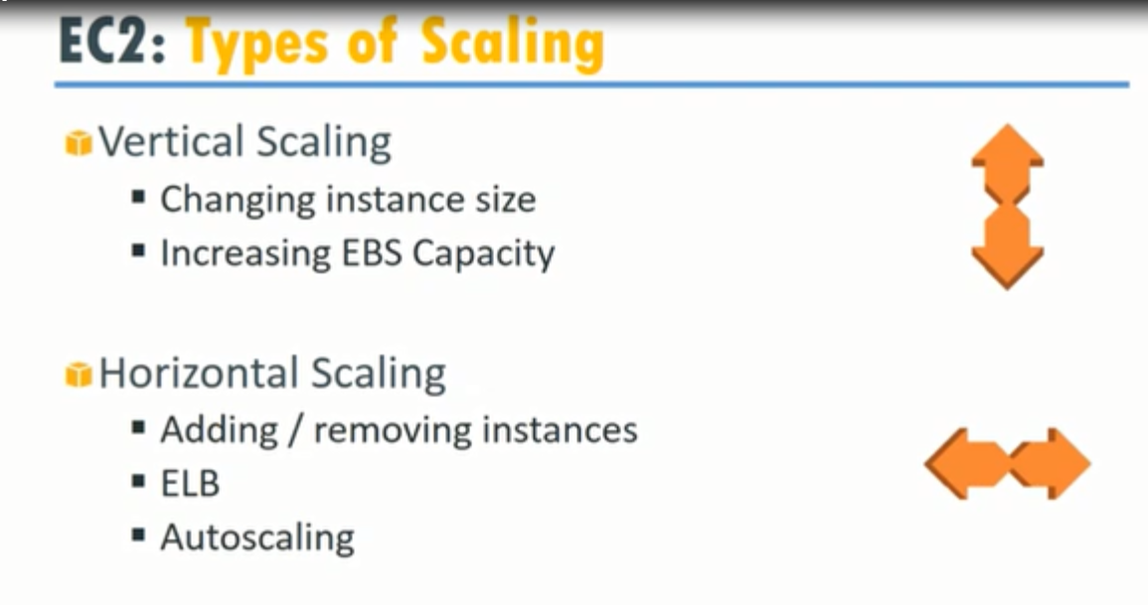

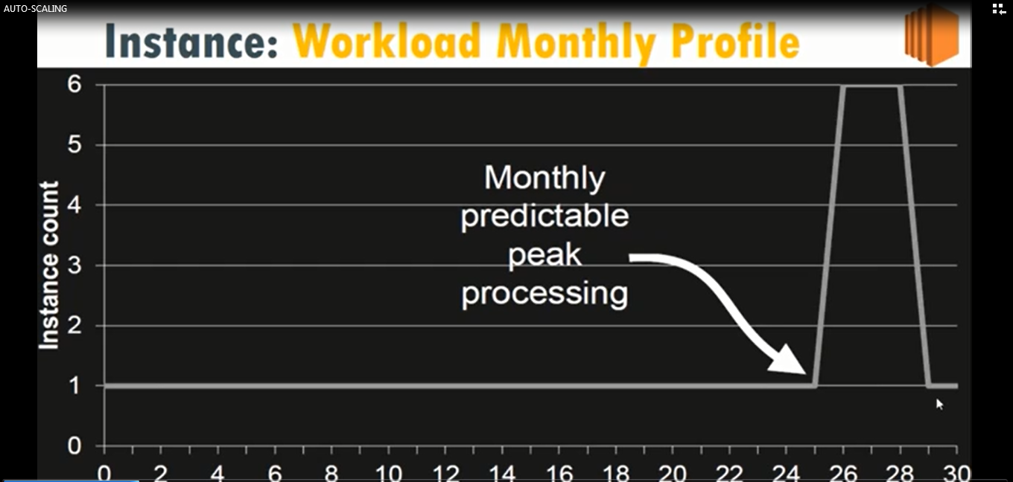

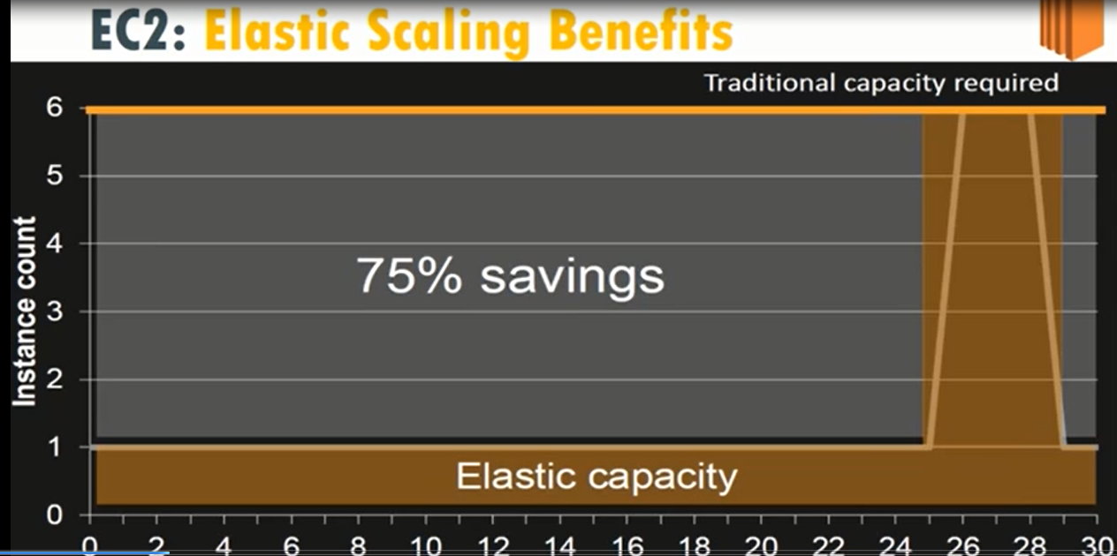

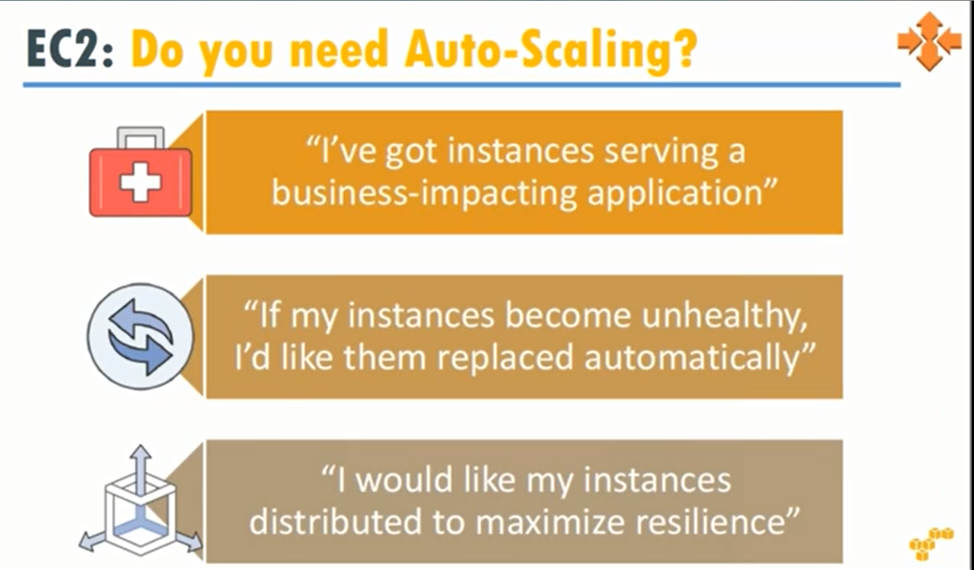

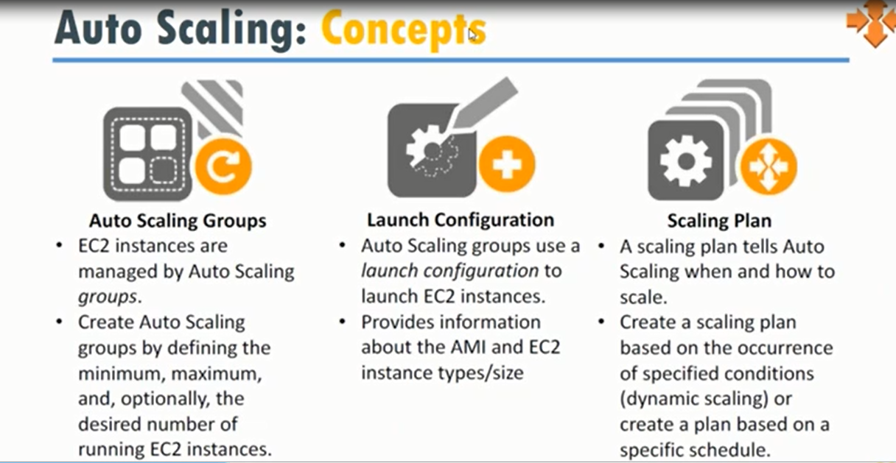

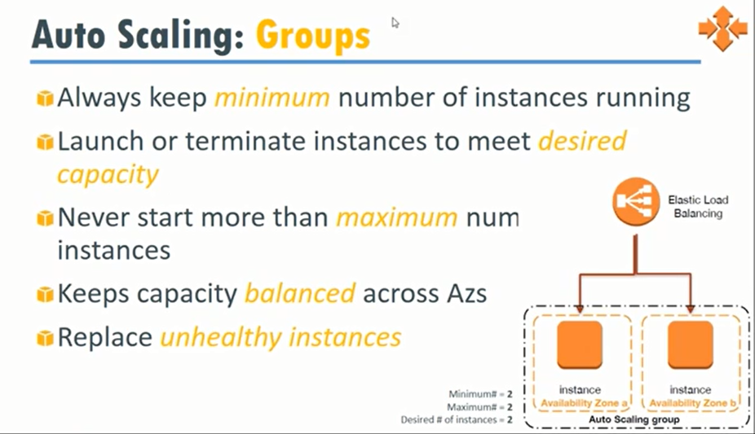

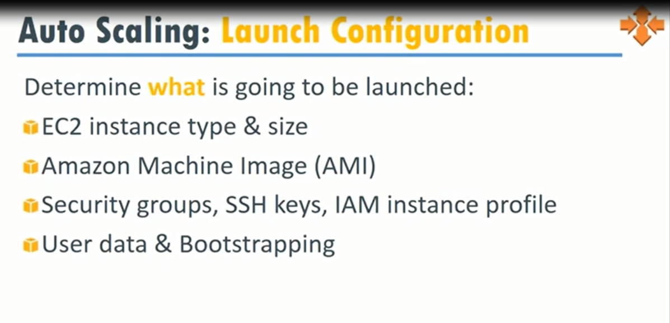

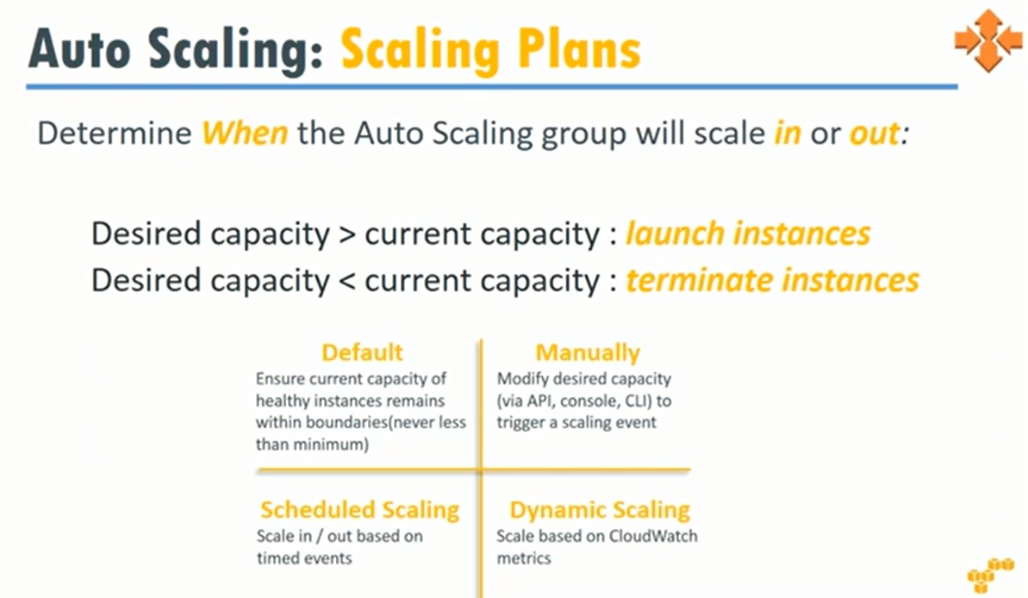



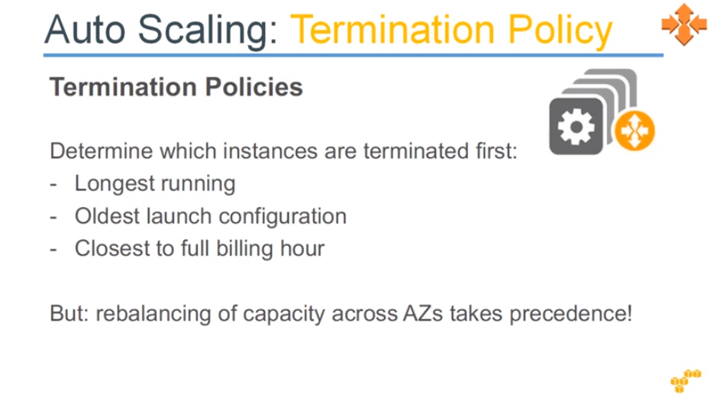

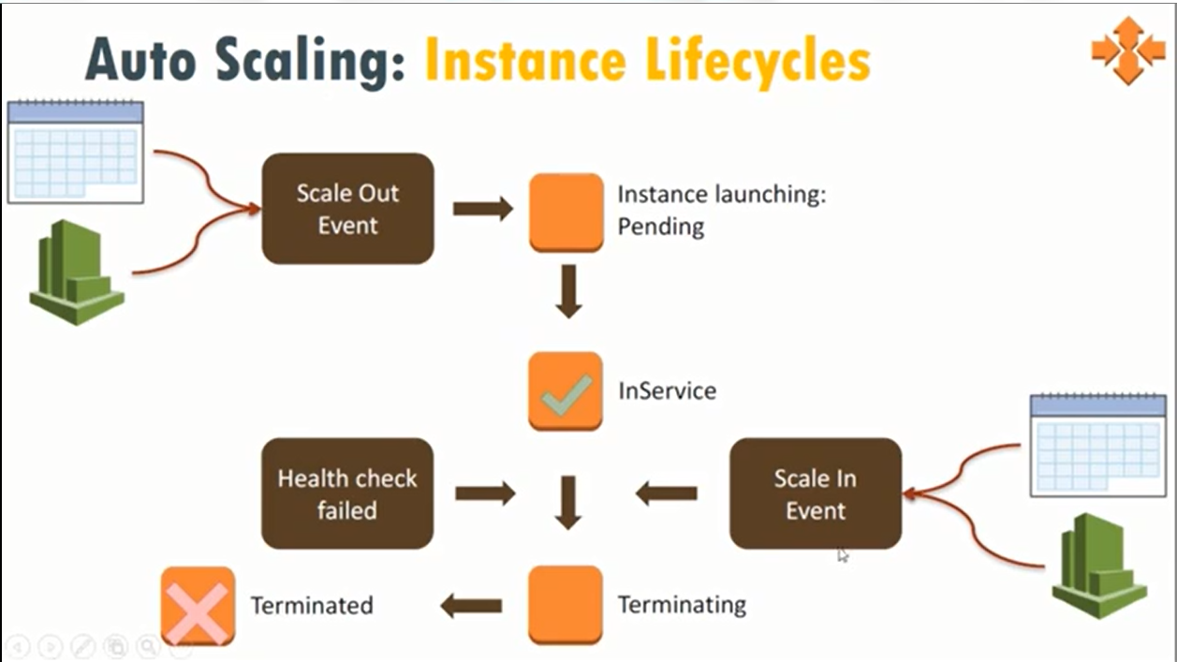

***To configure the Auto Scaling***

* Login to AWS console
* Go to EC2
* Create instance Amazon linux
* Select free tier
* Next
* Next
* Add rule
* http
* review and launch
* login to instance
* $ sudo su –
* # yum install httpd
* # service httpd start
* # chkconfig httpd on
* # cd /var/www/html
* # cat > index.html
* This is my website
* Check the website by using web browser
* Select the instance
* Click on actions
* Select the image option
* Create image
* Give the name of image
* Click on AMIS
* Check the image
* Click on auto scaling
* Create auto scaling group
* Check the box create a new launch configuration
* Click on my AMI
* Select the image
* Click on configuration details
* Give the name of configuration
* Click on add storage
* Click on configure security groups
* Click on add rule
* Select http
* Create security group
* Select the group name ---- auto scaling
* Click on review
* Click on create launch configuration
* Choose the existing key pair
* Create launch configuration
* Give auto scaling group name
* Group size – 2
* Select 2 subnets
* Click on configure scaling policies
* Select use scaling policies
* Select scale between 2 & 4
* Click on scale the auto scale policy on bottom of the page
* Execute policy option – add new alarm
* Give the notification name
* Give the email id
* Whenever average CPU utilization > 90%
* For at least 1----5 minutes
* Click on create alarm
* Take the action create 1 instance
* Now select decrease policy
* Add new alarm
* Whenever the CPU utilization < 60%
* For at least 1----5 minutes
* Create alarm
* Remove one instance
* Click on add notification
* Click on configure tags
* Name: auto app server
* Click on review
* Mean while delete the instance
* Click on create auto scaling group
* Check the group
* Click & check the tabs
* Click on instance tab refresh
* Check the 2 instances
* Go to EC2 instances
* Check the instances
* Check the instances
* Go to auto scaling
* Click on scaling policies to check fake utilization
* Click on actions
* Click on edit
* Alarm value make it 100
* Wait 5 minutes
* If it is not working
* Login into instance
* Give top command ( #top )
* Check the CPU load average
* Then run the command
* # yes > /dev/null &
* Mean while check the web sites by using the ip address of instances
* Now check the instance is created or not
* If it is not work due to network problem, delete instance
* Check the new instance is created or not
* After practice delete auto scaling group first
* Then delete the instances.

**Date: 3/3/2020**

**Elastic Load Balance**

Elastic load balancing distributes incoming application or network traffic across multiple targets such as Amazon EC2 instances, Containers and IP addresses in multiple availability zones. Elastic load balancing scales your load balancer as traffic to your application changes over time. It can automatically scale to the vast majority of workloads.

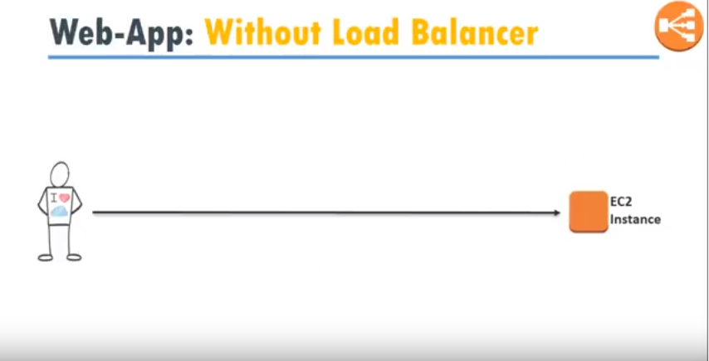

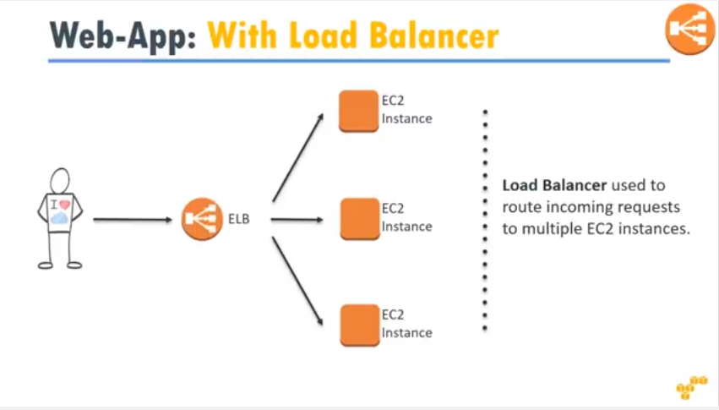

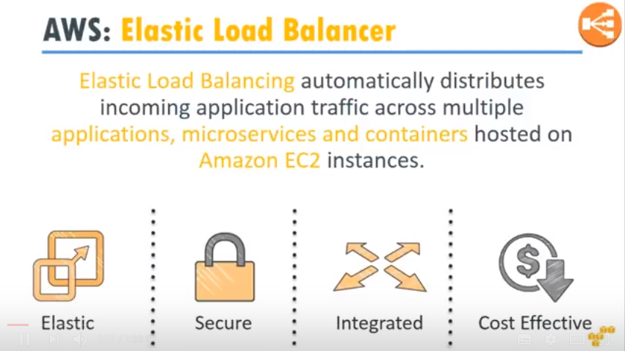

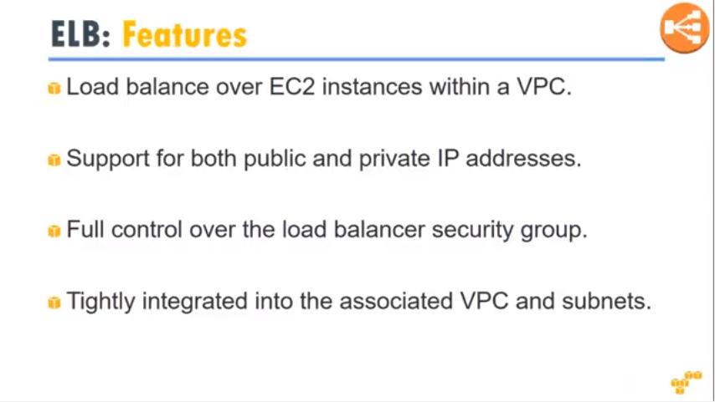

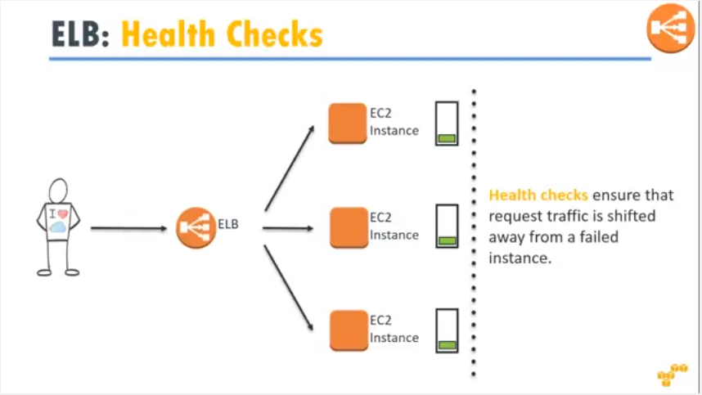

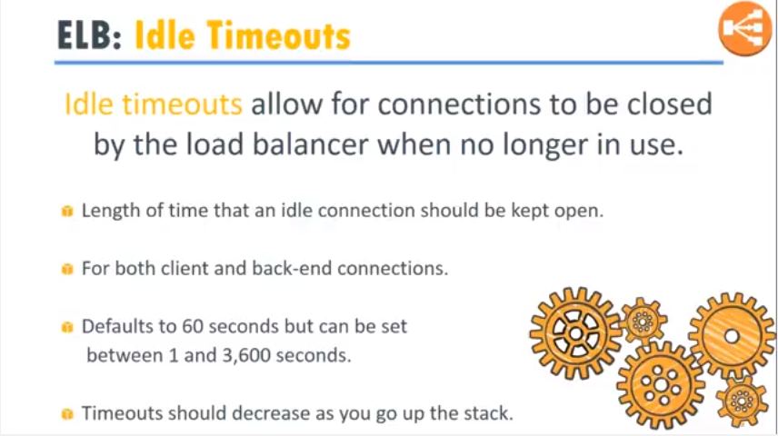

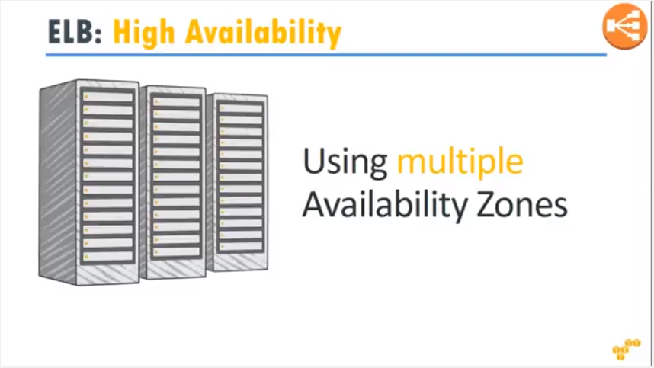

1. Launch 2 instances with apache web server in separate availability zones
2. Check the web sites are running
3. To configure elastic load balancer

* Expanding load balancing
* Select load balancer
* Click on create load balancer
* On welcome to ELB
* Select “application load balancer”
* Click on continue
* Click on configure load balancer
* Name: omnielb
* Schema – internet-facing
* Drag down
* Under listeners, provide
* Load balancer protocol – httpd
* Load balancer port – 80
* Under availability zones
* Select all zones
* Click on configure security settings
* Use defaults
* Click on configure security groups
* Select create a new security groups
* Click on configure routing
* Name: sales app
* Click on register targets
* Drag down the page
* Click on add register
* Verify the instances are register or not
* Click on review
* Verify
* Check the summary
* Drag down
* Click on create
* Verify load balancer successfully created

***Verification***

* To verify websites are coming through load balancer
* Go to EC2 dashboard panel
* Expanding load balancing
* Select the load balancer
* Copy load balancer DNS name
* In browser type load balancer DNS name
* Verify website by frequently refreshing browser ( press f5 )
* On each refresh one by one the servers will display

**Date: 4/3/2020**

**Amazon cloud watch**



Amazon Cloud Watch is a monitoring service to monitor your AWS resources as well as the applications that you run on AWS.

***Cloud watch objects***

* Dashboards – Creates dashboards to see what is happening with your AWS environment
* Alarms – Allows you to set Alarms that notify you when particular thresholds are hit
* Events – Cloud Watch events helps you to respond to state changes in your AWS resources.
* Logs – Cloud Watch logs helps you to aggregate, monitor, and store logs

***What can cloud watch do?***

Cloud watch can monitor things like

* EC2
* Dynamo DB
* RDS DB instances etc
* Custom Metrics generated by your applications and services
* Any log files your applications generate

***Cloud watch and EC2***

Host Level Metrics Consists of

* CPU
* Network
* Disk
* Status Check

**Note:** RAM utilization is a custom metric! By default EC2 monitoring is 5 minute intervals, unless you enable detailed monitoring which will then make it 1 minute intervals.

***How long Metrics stored***

* By default – 2 weeks. You can retrieve data that is longer than 2 weeks using Get Metric Statistics API or by using third party tools offered by AWS partners
* You can retrieve data from any terminated EC2 or ELB instance for up to 2 weeks after its termination

***Metric Granularity ?***

* It depends on the AWS service. Many default metrics for many default service are 1 minute, but it can be 3 or 5 minutes depending on the service
* For custom metrics the minimum granularity that you can have is 1 minute.

***Cloud Watch Alarms***

You can create an alarm to monitor any Amazon Cloud Watch metric in your account. This can include EC2 CPU utilization, Elastic Load Balancer Latency or even the charges on your AWS bill. You can set the appropriate thresholds in which to trigger the alarms and also set the what actions should be taken if an alarm state is reached. This will be covered in a subsequent lecture.

***To configure Amazon cloud watch***

* Login to Amazon web console
* Click on services
* In the management tools
* Click on cloud watch
* Click on alarms
* Select EC2 metrics
* Click on per-instance metrics
* From create alarm page
* Select 1 select metric
* In search box provide instance id or name
* Under metric name, select CPU utilization check box
* Click next
* On create alarm page
* Select 2 define alarm
* Under alarm threshold
* Name: omni cpu utilization
* Description – cputest
* Under whenever cpu utilization
* Is >= 30
* For 1 consecutive periods
* Drag down
* Under actions
* Whenever this alarm – state is alarm
* Send notification to – click on new list
* Send notification to – cpu topic omni
* Email: [adminomni@omni.com](mailto:adminomni@omni.com)
* Click on create alarm
* Click on I will do it later
* Go to mail account check the mail
* Once mail is checked
* Config status – pending confirmation
* Verify the link from your mail
* Click on confirm subscription
* Verify by this output
* After confirmation from email config status has become blank
* Now login to instance
* Switch to root account
* # top
* # stress –cpu 40 –timeout 1000
* Now check top command
* Go to cloud watch service
* Check the status
* After 5 minutes alarm is generated
* Go to email and check mail

**Date: 5/3/2020**

**Simple notification service (SNS)**

Amazon SNS is a highly available, durable, secure fully managed pub/sub messaging service that enables you to decouple micro services, distributed systems and server less applications. Amazon SNS provides topics for high throughput, push-based, many-to-many messaging.

***To configure simple notification service***

* Login to AWS console
* Select application integration service
* Click on simple notification service
* From SNS dashboard
* Select topic
* Click on create new topic button
* In create new topic provide topic name and display name
* Click on ARN link

***To create subscription***

* Click on create subscription
* Protocol: EMAIL
* Endpoint = email address
* Click on create subscription

***Verification***

* Now subscription is pending state
* Go to your mail account
* Click on the mail
* Click on confirm message

***To publish message to an SNS topic***

* Click on topics
* Select a topic
* Choose publish to topic
* In the publish message, for subject enter a subject line for your message and for message enter a brief message
* Choose publish message
* Check your mail to confirm the message

**Amazon cloud formation**

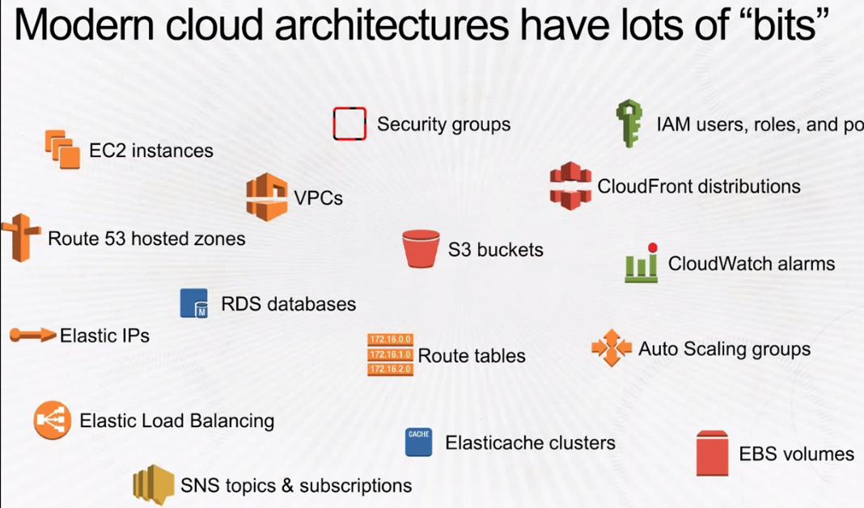

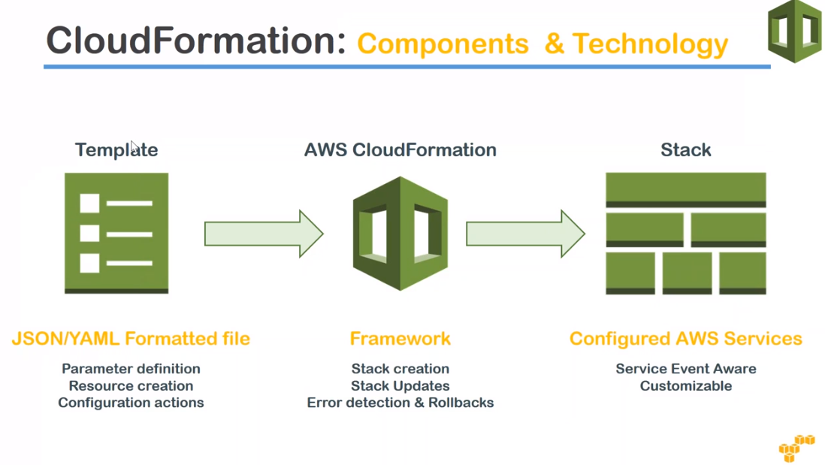

***To launch Amazon EC2 instance in security***

* Login to web console
* Click on service
* Management and governance tools
* Click on cloud formation
* Click on stacks
* Create stack
* Select template is ready
* Next
* Enter stack name, omni stack
* DB name, DB password, DB root password, DB user, instance type: t2.micro, key name: aws, click next
* Give tags
* Click next
* Create stack

***To delete the stack***

* select the stack
* delete the stack

**Date: 9/3/2020**

**Route 53**

**(DNS in the cloud)**

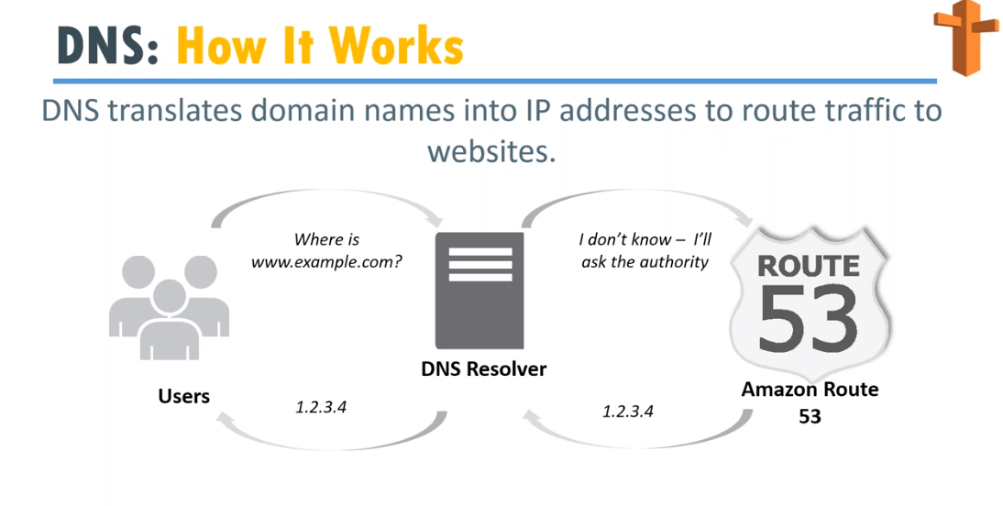

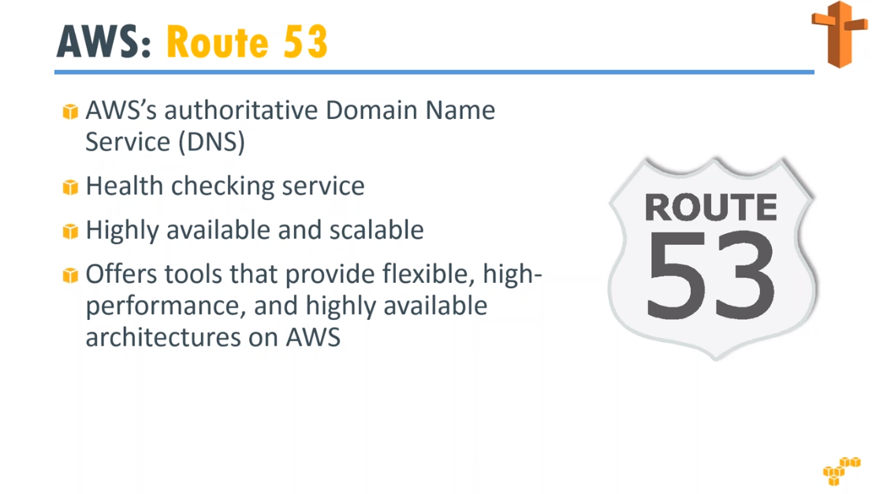

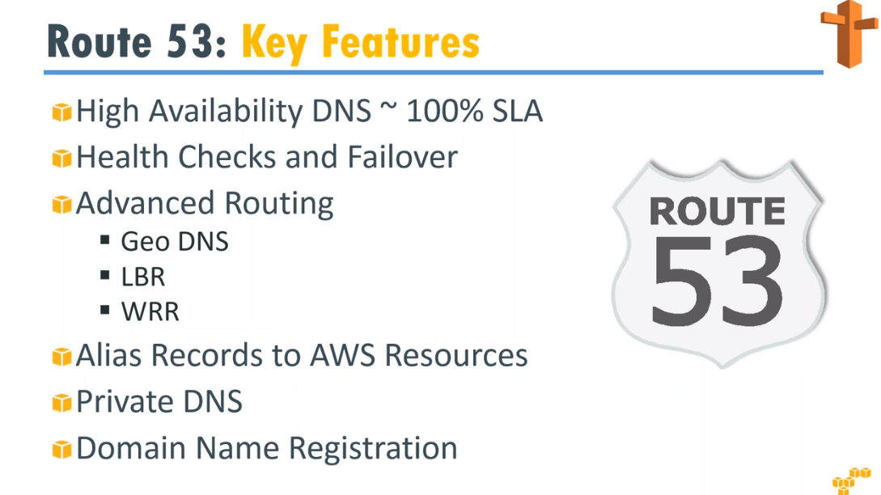

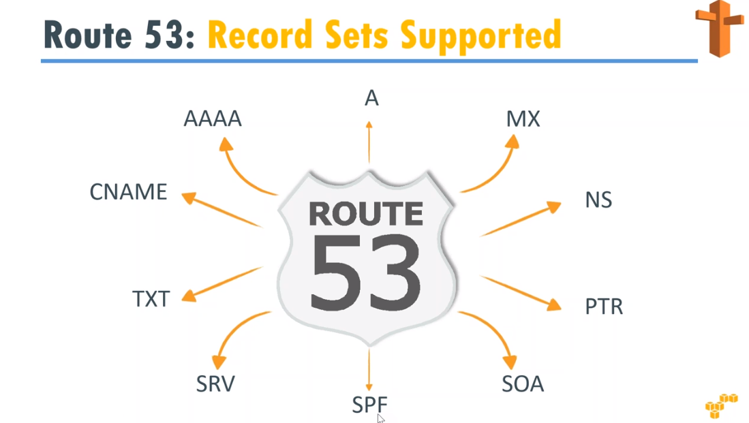

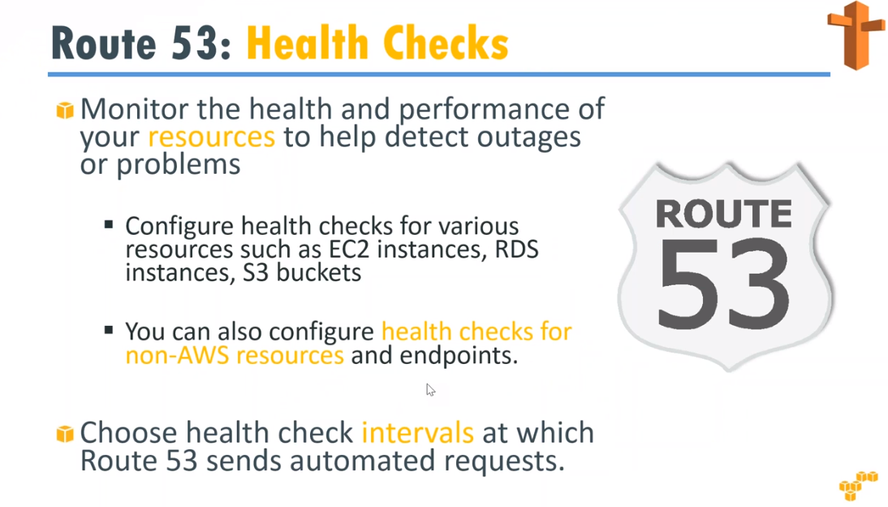

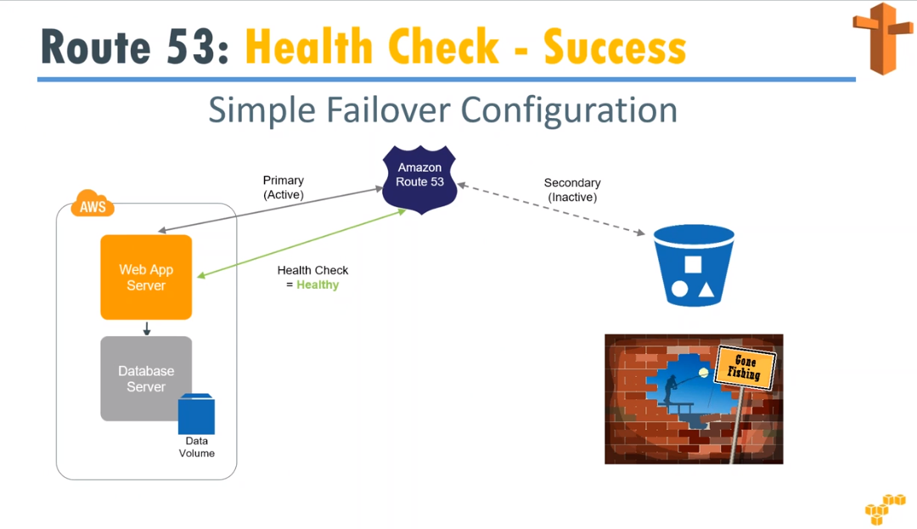

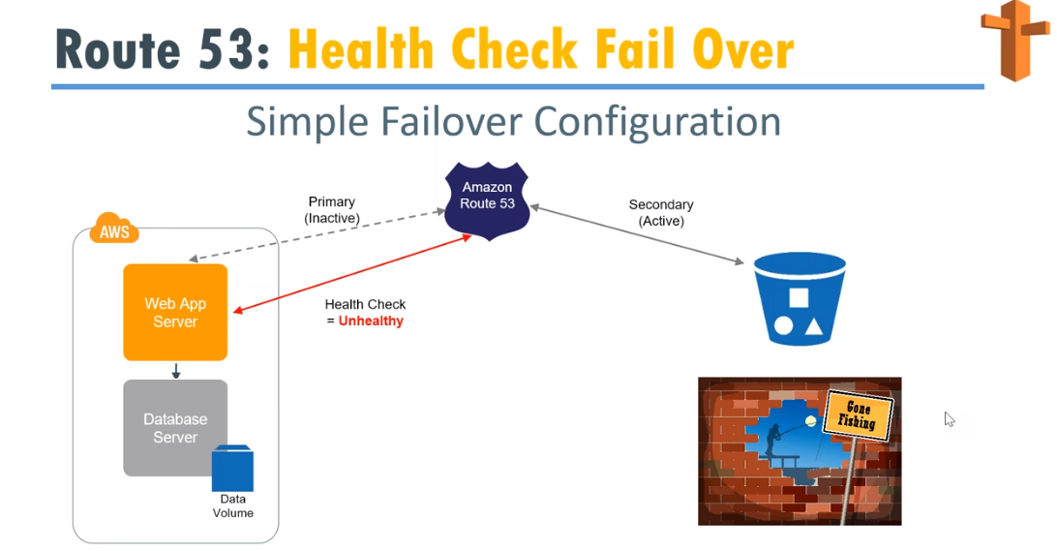

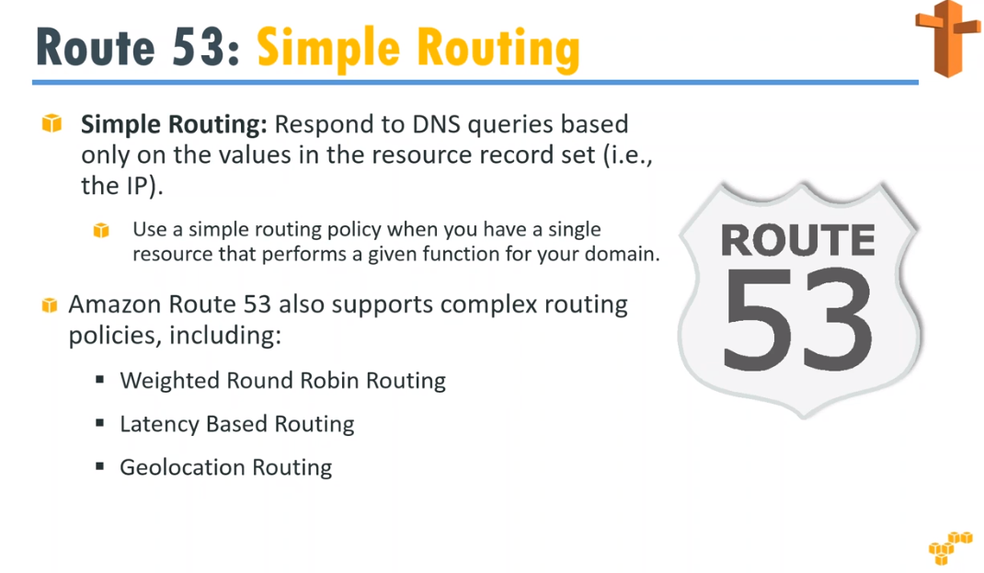

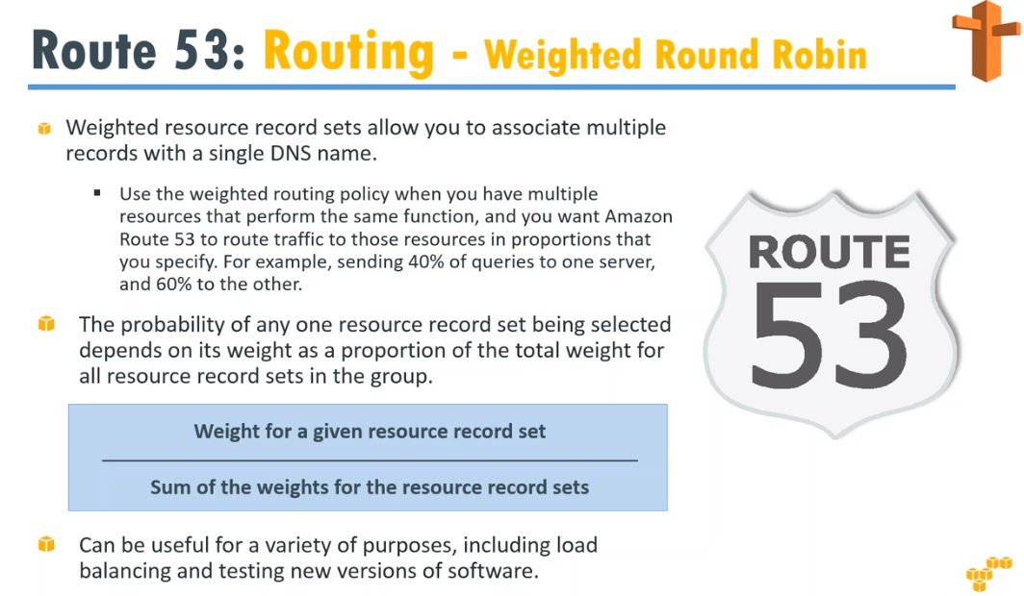

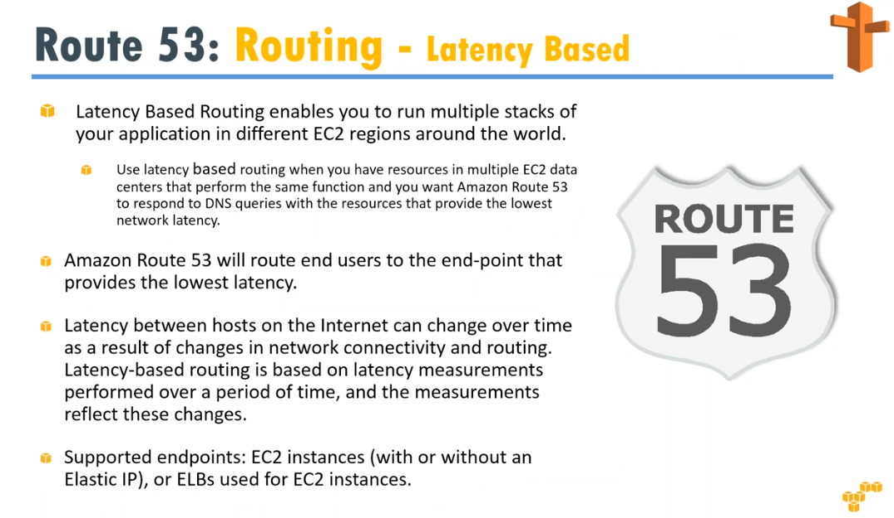

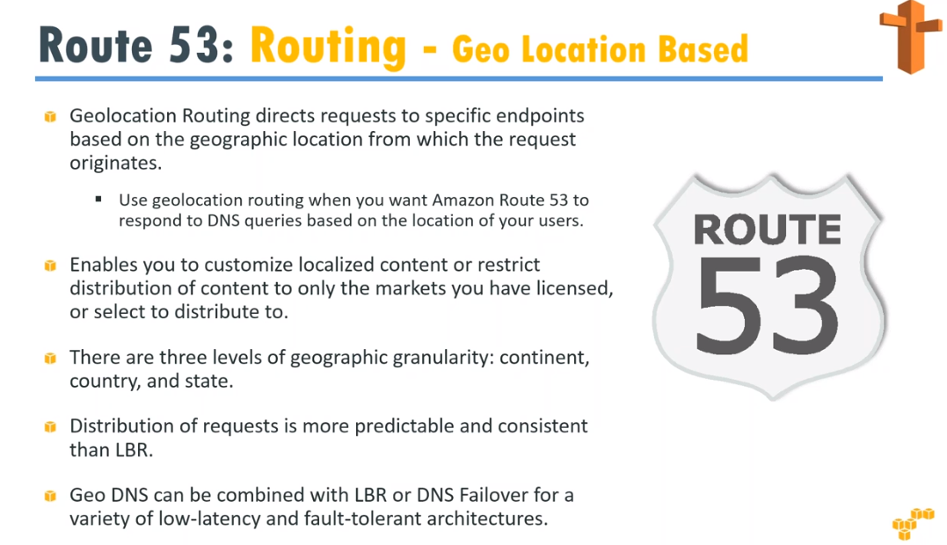

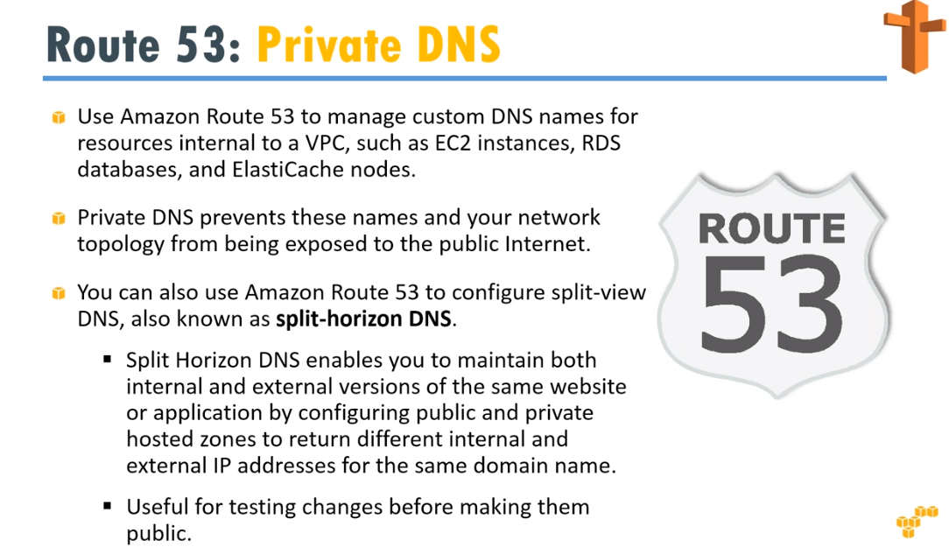

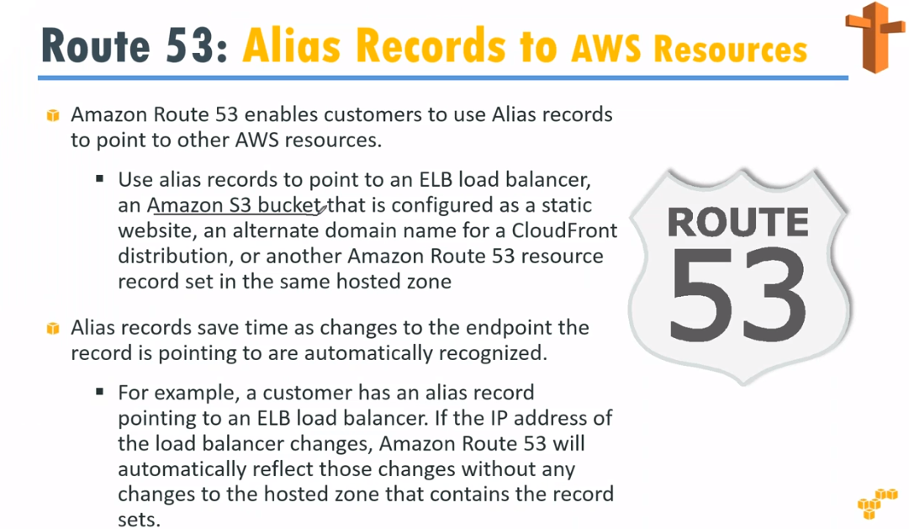

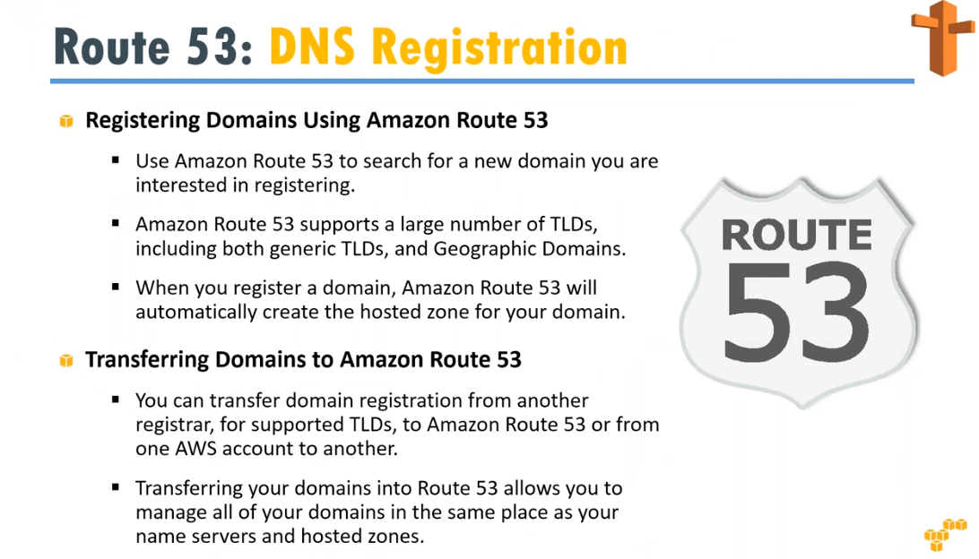

***To configure R53***

* create two linux instances
* configure web sites
* select “networking and content delivery”
* click R53 services
* Route53 dashboard wizard opens
* DNS management
* Get started now
* Create a hosted zone (godaddy.com or freenom)
* Go to freenom
* Create a new domain
* Find your new domain
* Select free domain
* Get now
* Click on check out
* Select period 1 month
* Click on continue
* Click on complete order
* Click on my domain
* Go to route53
* Give the domain name (your domain)
* Click on create
* Click NS record
* From right side panel copy the NS record values copy into notepad
* Remove the dots end of the domains
* Go to freenom
* Choose the domain click on manage domain
* Click on management tools
* Select nameservers
* Select custom name servers
* Copy one by one name servers and paste
* Click on change name servers
* Come back to route53
* Click on create a record set
* TTL seconds 60
* In value field copy the public IP
* Click on create
* Go ACM (certificate manager)
* Request a public certificate
* Click on request a certificate
* Enter the domain name
* Vamshi18.tk
* Next
* Select dns validation
* Next
* Review
* Click on confirmed request
* Expand the domain name
* Select the route53 domain
* Copy the CNAME
* Go to route53 refresh the page
* Check CNAME is updated
* Check the web site

**Date: 11/3/2020**

**Cloud front**

**Amazon cloud front** is a content delivery network (CDN) offered by Amazon web services. Content delivery networks provide a globally-distributed network of proxy servers which cache content, such as web videos or other bulky media, more locally to consumers, thus improving access speed for downloading the content.

**What is object:** Amazon S3 has various features you can use to organize and manage your data in ways that support specific use cases, enable cost efficiencies, enforce security, and meet compliance requirements. Data is stored as objects within resources called “buckets”, and a single object can be up to 5 terabytes in size.

**An edge location** is where end users access services located at AWS. They are located in most of the major cities around the world and are specially used by Cloud Front (CDN) to distribute content to end user to reduce latency. It is like frontend for the service we access which are located in AWS cloud.

**Cloud Front deliver content:** Cloud Front servers content through a worldwide network of data centers called edge locations. If cloud front has a cached copy of the requested file, Cloud front delivers it to the users, providing a fast (low-latency) response.

***Configuration of Cloud front***

* Open cloud front
* Create distributions
* Get started
* Choose the name Ex: wwwteacom.s3.amazonaws.com (of S3 bucket with object)
* Restrict bucket access: YES
* Origin access identify: Create a new identity
* Grant read permissions on: Yes, update bucket policy
* Price class: Use all edge locations (best performance)
* Create distribution

***Open distribution:***

* Left side select Distributions
* Wait for status in Prog
* Copy the domain name done path
* Open new browse
* Copy ************* cloud front.net/index.html enter
* Open with automatically S3 bucket content delivery

***How to delete the cloud front***

* Open cloud front
* Check the box web
* Click on disable
* Yes, disable
* Close

**Elastic Bean Stalk**

With elastic bean stalk, you can quickly deploy and manage applications in the AWS cloud without having to learn about the infrastructure that runs those applications.

Elastic bean stalk reduces management complexity without restricting choice or control

You simply upload your application, and elastic bean stalk automatically handles the details of capacity provisioning, load balancing, scaling and application health monitoring.

***Difference between EC2 and Elastic bean stalk***

**AWS EC2:**

* EC2 is a service of amazon which helps you to create and launch servers in the amazon cloud.
* These servers are called instances and they are configured behind a load balancer when we create a bean stalk application.
* With a single instance, we can launch **n** number of instances.
* You pay for the time and for what you have used.

**AWS Elastic bean stalk:**

* A bean stalk infrastructure contains EC2 instances, security and scaling groups and many more AWS components.
* It is beneficial for the purpose of deploying elastic cloud applications
* Bean stalk doesn’t charge for the additional resources you have been provided with
* Elastic bean stalk supports a PHP stack. You can keep your site in version control and easily deploy to your environment whenever you make changes.

***Configuration of Elastic Bean Stalk***

* Login to AWS console
* Select compute
* Click elastic bean stalk
* Click on get started
* Create web app
* Application name: tomcat app
* Env.name: tomcatenv
* In platform box select Tomcat
* Select upload your code
* Upload calendar.war
* Click on upload file
* Click on create application

***Verification***

* Tomcat application at backup ground is getting started
* Progress on screen displayed
* Verify
* Click on the URL link
* Verification
* Open web browser
* Click on URL link
* Website is open

***To deploy another war file***

* Click on upload
* Choose the file
* Click on deploy
* Click on URL
* Verify the website
* To remove elastic bean stalk
* Select action button
* Click on delete application
* application will terminate

***To delete elastic bean stalk bucket policy is created in S3 bucket***

* select S3
* click on switch on old console
* select elastic bean stalk bucket, click properties
* select permissions
* click on edit bucket policy
* in bucket policy editor
* click delete to remove policy
* click on ok
* click on save

***Simple Queue Service(SQS)***

Amazon simple queue(sqs) is fully message queuing service that enables you to decouple and scale micro services, distributed systems, and serverless applications. Get started with SQS in minutes using the AWS console, command line interface or SDK of your choice, and three simple commands

Amazon SQS works on a massive scale, processing billions of messages per day.you can scale the amount of traffic you send to Amazon SQS up or down without any configuration Amazon SQS also provides extremely high message durability,giving you and your stakeholders added confidence

***Configuration:***

* login to console
* select simple queue service

1. click on get started
2. create new queue
3. provide the values
4. remaining are defaults
5. click quick-create queue bottom
6. verify queue is created

* select the queue

1. click queue action button
2. click on send message
3. write the message

* To view the message

1. Select the queue
2. Click on action button
3. Select the option “view/del” the message
4. Click start polling for message
5. Verify the message is in queue

* To delete the message

1. Select queue
2. Click on action button
3. Delete message